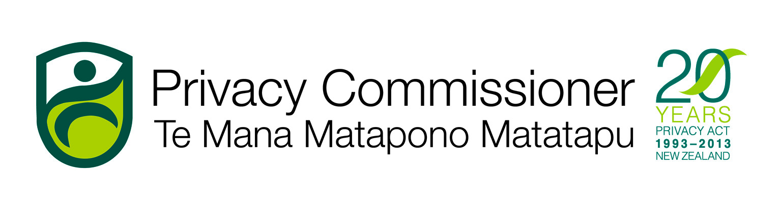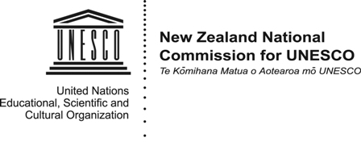
MEDIA ADVISORY
5 February 2014
OWLS: teaching children to be wise about online privacy
A new resource to help teachers teach internet privacy issues to primary and intermediate school students will be launched in Wellington on 11 February to coincide with Safer Internet Day (www.saferinternetday.org).
The OWLS project has been developed by the Office of the Privacy Commissioner and NetSafe, in partnership with the NZ National Commission for UNESCO.
OWLS is a series of 24 modules (http://netsafe.org.nz/owls/) on different aspects of managing personal information online. Each module has a lesson plan which teachers can use or adapt to suit their cyber-education classroom needs.
The modules have four themes:

- Own your information
- Wait before you upload
- Lock your information
- Safety first

Media are invited to the launch of the OWLS resource. The guest speaker is the Hon Nikki Kaye, the Associate Minister of Education and Minister of Youth Affairs. There will also be a classroom demonstration of how OWLS can be used with students.
9.30 - 10.30am, Tuesday, 11 February 2014
Tawa Primary School, Oxford Street, Tawa, Wellington
To attend or receive more information, contact Charles Mabbett 021 509 735.
