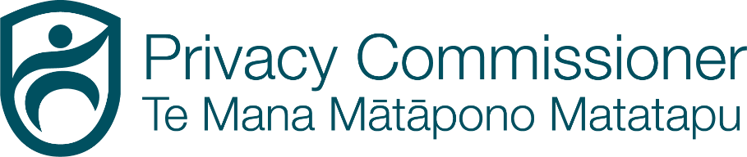
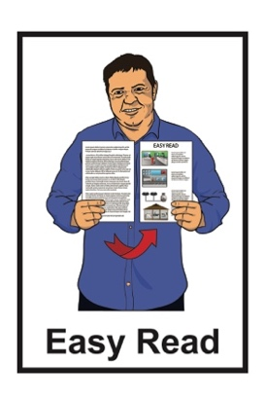

Taking part in some research about privacy
for children and young people

Survey form
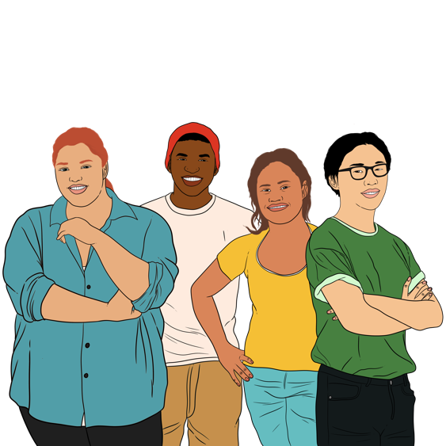
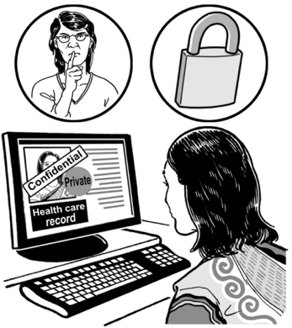

Published: October 2023

Before you start

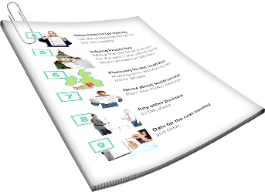
This is a long document.

It can be hard for some people to read a document this long.

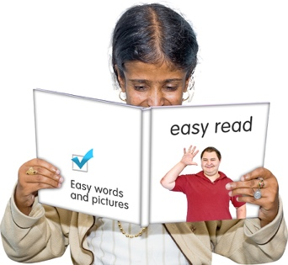
Some things you can do to make it easier are:
read it a few pages at a time
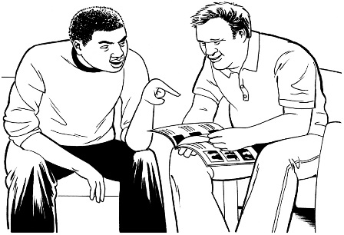
set aside some quiet time to look at it
have someone read it with you to support you to understand it.

What you will find in here

Page number:

What is in this document 4

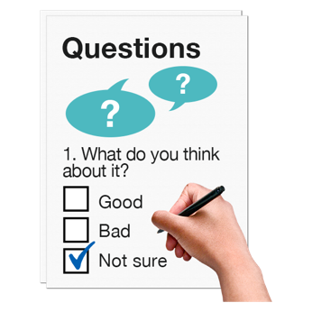
How to take part 9

Who are you? 14

Privacy in Aotearoa
New Zealand 18
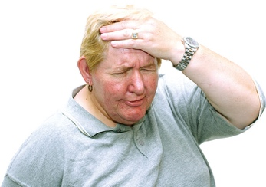

Your worries 26

Page number:

Keeping information about children
and young people safe 33

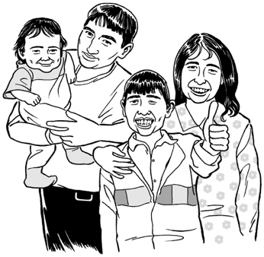
Whānau / families 39

Thank you 47

What is in this document

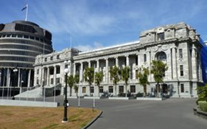
This document is by the Office of the Privacy Commissioner.

The Office of the Privacy Commissioner is the part of the Government that is in charge of privacy.

The Government cannot tell the Office of the Privacy Commissioner what to do.

Privacy means being in charge of information about yourself.

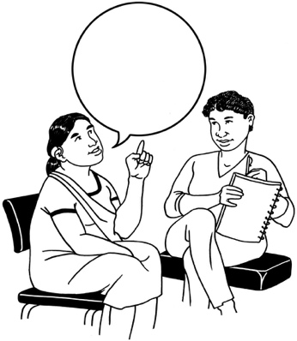
Privacy means you know:
who has information about you
how information about you is used
how information about you is kept safe.

In this document we will call the Office of the Privacy Commissioner the OPC.

When you see the words we / us in this document it means the OPC.

The OPC is doing a survey about privacy for children and young people.

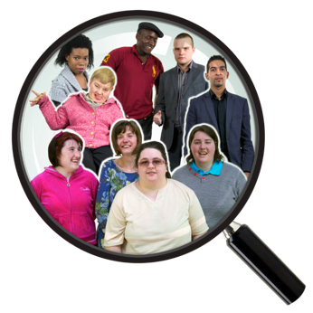
A survey is a way to do research by asking a lot of people to answer questions.

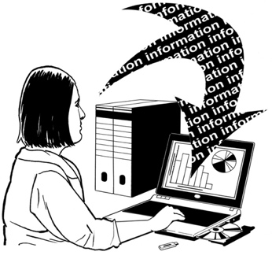
Research is when someone:
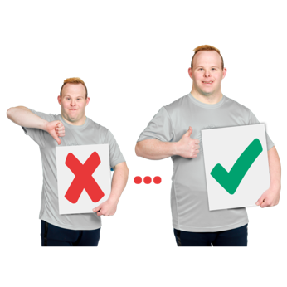
looks at what has happened
tries to find ways to do things differently.

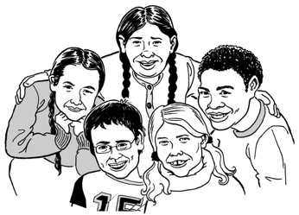
Children and young people means everyone who is younger than 18 years old.

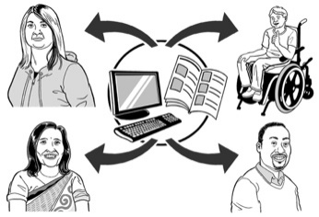
Aotearoa New Zealand has some rules for how adults should share information about children and young people.

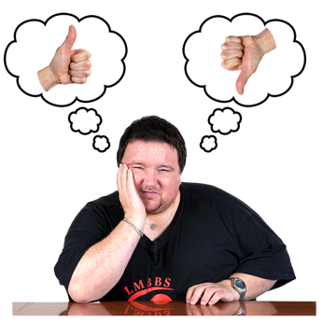
We want to know how well the rules about privacy for children and young people work.

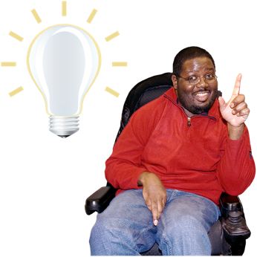
We want to know if you think information about children and young people is respected.

Respect means treating something like it is important.

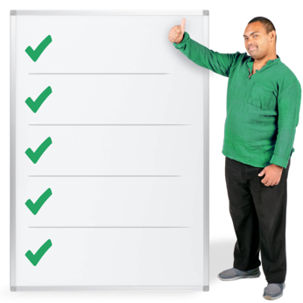
We will use the information from this research to decide if we need to:
make the rules stronger
make new rules.

You can find out more about this research in the Easy Read document:

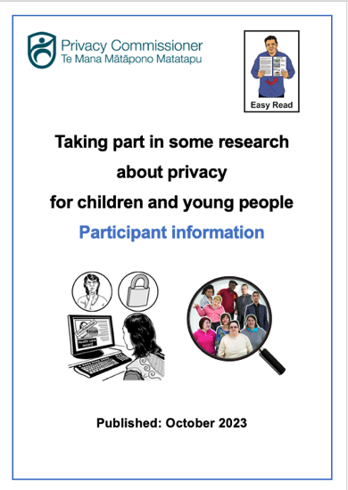
Taking part in some research about privacy for children and young people:
Participant information

https://tinyurl.com/mt75x7nw

How to take part

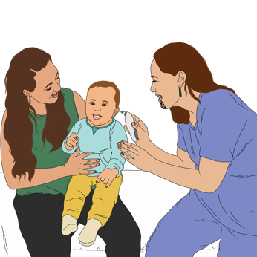
This survey is for adults who look after children and young people like:
whānau / families
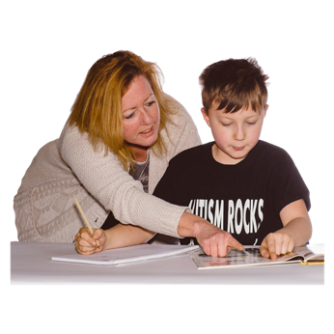
healthcare workers
teachers
social workers.

Social worker means someone whose job is to support people who are having a hard time.

There will be a survey for children and young people next year.

The questions for the survey are in this document.

If you want to take part in the survey you can write your answers on this document.

You can also answer the survey online at:

https://tinyurl.com/mt75x7nw

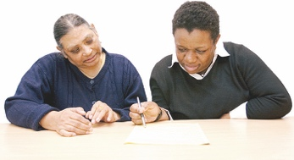
You can ask someone to support you to answer this survey like a:
friend
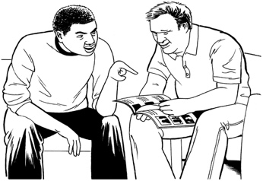
family member
support worker.

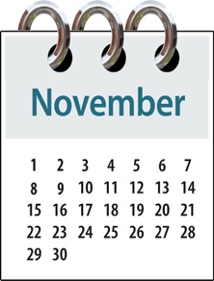
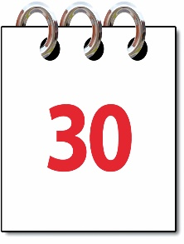
You need to get the survey back to us by:

30 November 2023

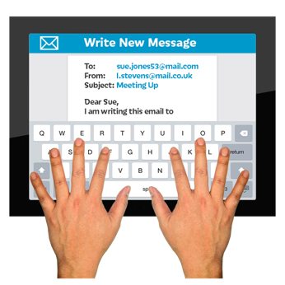
When you have done the survey you can send it to us by email at:

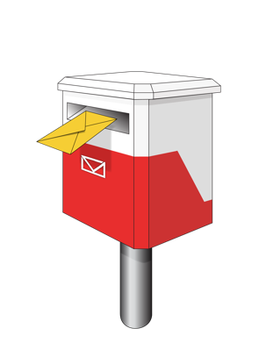
children@privacy.org.nz

You can also post your survey to us at:

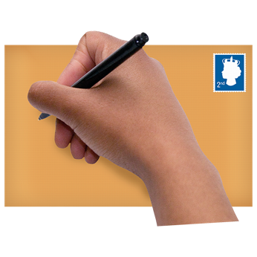
Office of the Privacy Commissioner
Children’s Privacy Project
PO Box 10094
The Terrace
Wellington 6143

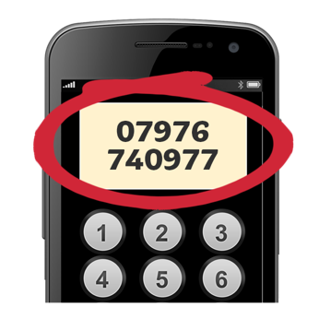
You can call us on the phone at:

0800 803 909

When you call we will make a time to talk.

You can phone us:
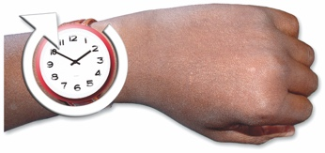
on Monday to Friday
from 10 am to 3 pm.

You can use the New Zealand Relay service when you call us.

If you find it hard to use the phone the New Zealand Relay service is for people who are:

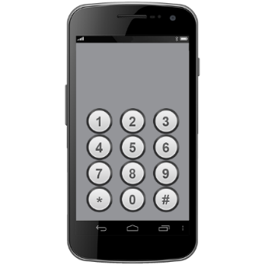
- Deaf / hard of hearing

- deafblind

- speech impaired / find it hard to talk.

You can find out more about the New Zealand Relay service at:

www.nzrelay.co.nz

Who are you?

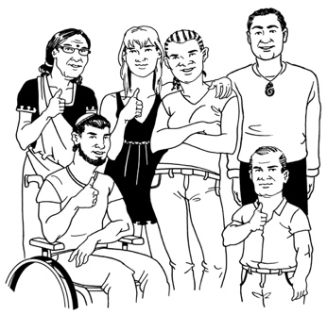
We think that different groups of people might have different worries about privacy.

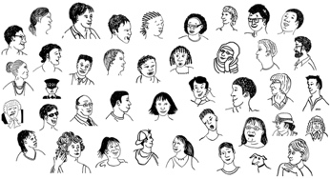
We need to make sure lots of different people answer our survey.

Your information will be confidential.

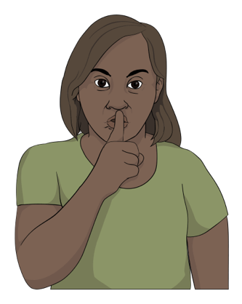
Confidential means that what you say will not be told to:
everyone
anyone who does not need to know.

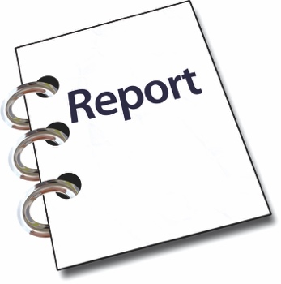
When the survey is finished we will write a report.

Report means a document that says:
how we did our research
what we found out
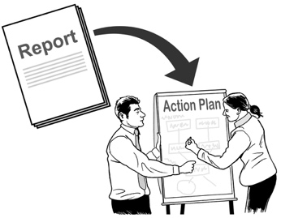
what we think should happen next.

The report will not use:
your name
any information that would tell people who you are.

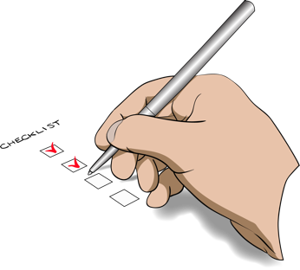
Put a tick inside the box beside your answer.

You can tick more than 1 box.

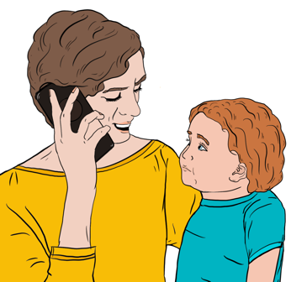
I am:

a parent / guardian / family member
a healthcare worker

a school / education worker

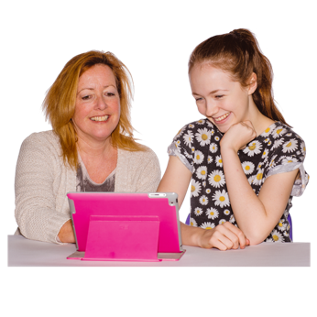
a social service worker

something else – please tell us on the line:

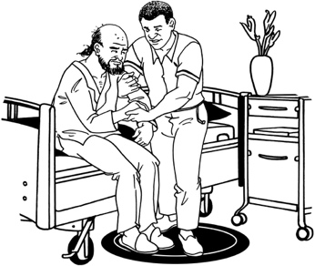
Social service means an organisation that assists people when they need support.

Privacy in Aotearoa New Zealand

We want to know how easy / hard it is to:
find information about privacy
understand information about privacy.

Your answers will assist us to work out if we need to change anything about the information we give to people.

Put a tick in the box beside your answer.

Do you know what the rules about privacy for children and young people are?

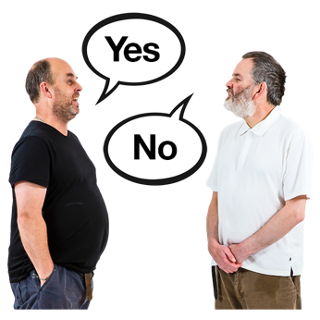
yes

no

If you said yes write on the lines where you would find the rules:

If you said no put a tick in the box beside where you would go to find out the rules:
Office of the Privacy Commissioner

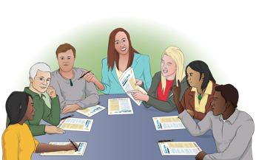
Netsafe

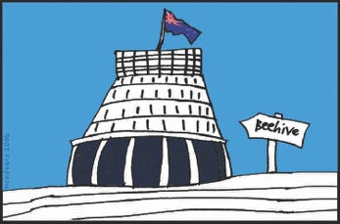
a professional body like New Zealand School Trustees Association

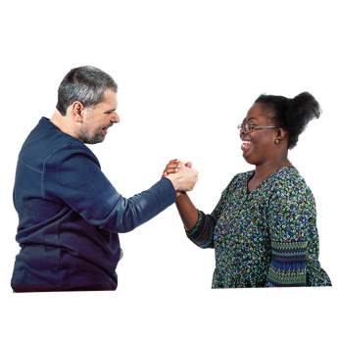
a government agency like Ministry of Health

friends / parents / people I work with

I would not be interested in finding out.
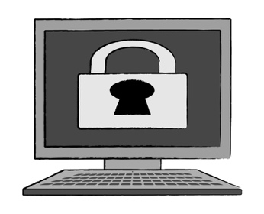
Netsafe is an organisation that provides advice about online safety.

The next 2 questions are only for people who work with children and young people for their job.

Write your answer on the lines.

How easy / hard is it to find information about the privacy rules for your job?

Write your answer on the lines.

Do you have the right information to help the children / young people you work with to understand their privacy rights?

The rest of the questions are for everyone.

Write your answer on the lines.

What do you think should change to make it easier for parents / whānau to keep information about their children and young people safe?

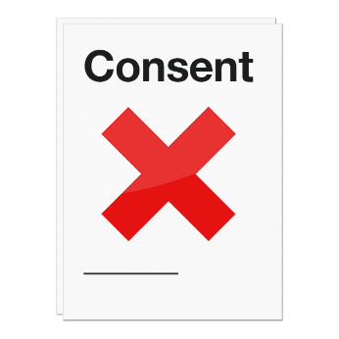
Sometimes information about children and young people is taken without consent from:
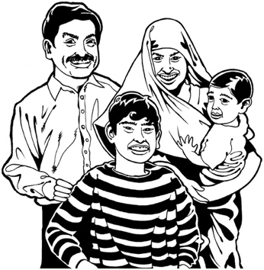
them
their whānau / family.

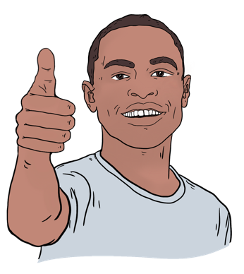
Consent means that you:
agree to do something
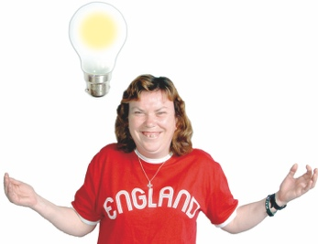
agree that someone else can do something.
understand what you are agreeing to.

Put a tick in the box beside your answers.

You can tick more than 1 box.

What would you do if information about a child / young person you look after was taken without consent?
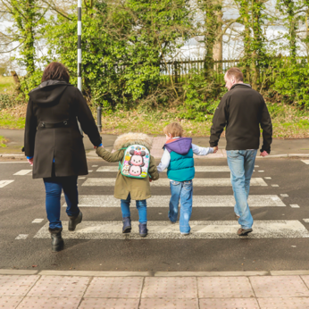

I would talk to other parents / guardians.

I would talk to a professional body like New Zealand School Trustees Association.

I would talk to the person / business who took the information.

I would go to the OPC website.

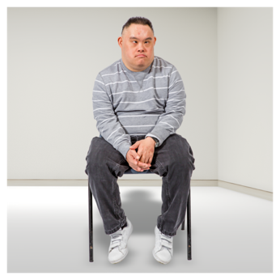
Here are some more boxes you can tick about what you would do if information about a child / young person you look after was taken without consent.

I would not do anything.
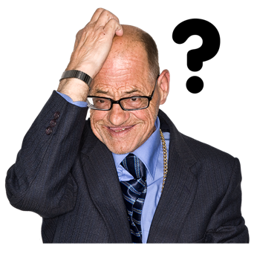
I do not know what to do.

I have not thought about this before

Your worries

Information about children and young people is used by:
organisations like Plunket
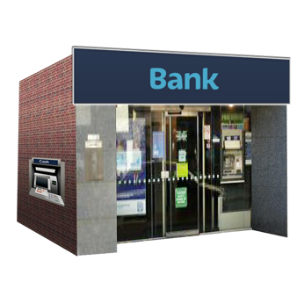
businesses like banks
websites
government departments like the Ministry of Health.

Sometimes some of these places do not take care of that information.

We will use these questions to assist us to work out if we need new rules about privacy for children and young people.

Put a tick in the box beside every answer that is true for you.

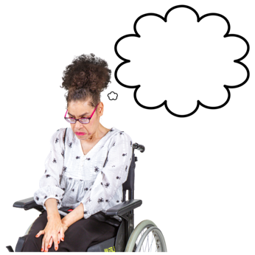
You can tick more than 1 box.

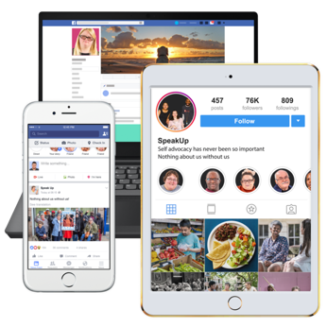
I worry about how information about a child / young person is used when that child / young person:

uses social media like Facebook

uses apps / computer programs for school

goes to school

uses health / social services

plays online games.

I have a different worry about times when information about a child is used.

If you said you have a different worry about times when information about a child / young person is used write about it on the lines:

Put a tick in the box beside every answer that is true for you.

You can tick more than one box.

What things worry you about how information about children and young people might be used?

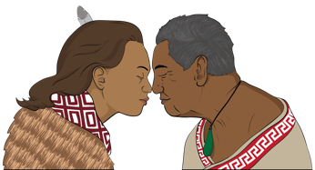
I worry that the mana / tapu of their information is not respected.
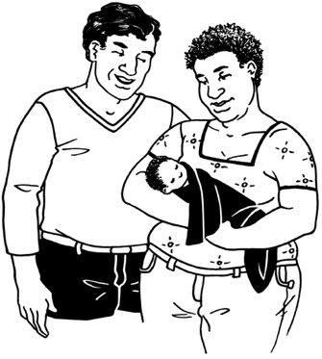

Mana is something that Māori believe everyone has from birth.

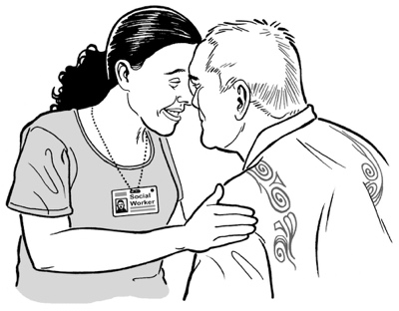
Mana is the spiritual life force / power that is found in all of the universe.

Having mana might affect how other people see / think about someone.
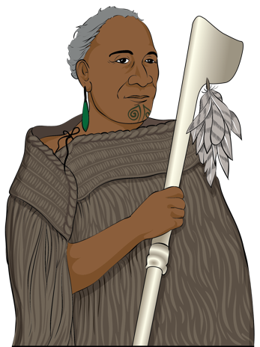
Tapu is a Māori word that means something is:
sacred / holy
special
set apart from ordinary things.

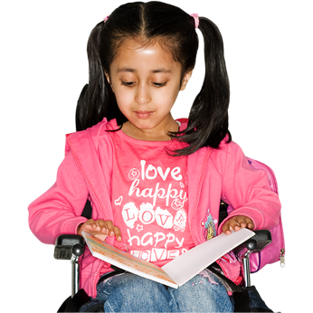
Here are more boxes you can tick about the things that worry you about how information about children and young people might be used.

I do not like the way children are asked for their information.

I worry that information is taken without consent.

Here are more boxes you can tick about the things that worry you about how information about children and young people might be used.

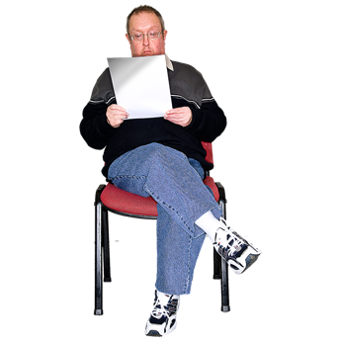
I do not know how the information will be used.

I do not know who will see the information.
I am worried that some of the information might be wrong.

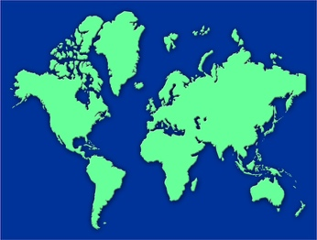
I am worried that wrong information cannot be fixed.

I am worried that people might find out where a child is.

I worry that businesses might show adverts to children.

Here are more boxes you can tick about the things that worry you about how information about children and young people might be used.
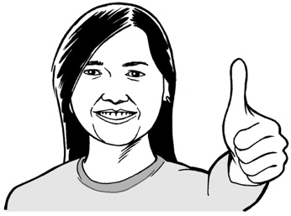

I do not worry about any of these things.

I have not thought about these things before.
I have a different worry about how information about children and young people is used.

If you have a different worry write it on the lines:

Keeping information about children and young people safe

This is a list of things that could assist with keeping information about children and young people safe.

Put a tick in the box beside all the things you think are a good idea.

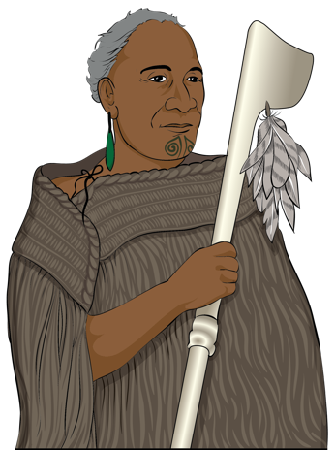
The mana / tapu of information about children and young people should be kept safe.

Information about children and young people should be given to their iwi / hapū.

Iwi means a Māori tribe.
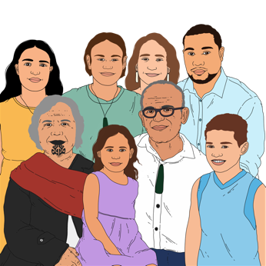
Hapū means a group that is part of an iwi.

A hapū is made up of several whānau / families.

Here are more boxes you can tick about things that could assist with keeping information about children and young people safe.

Websites should make it easy to see what they do with information about children and young people.
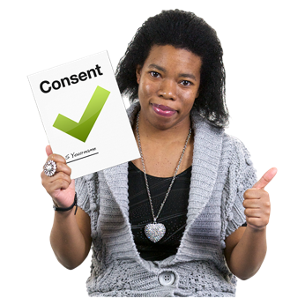
Everyone should make sure information about children and young people is always used with consent.

Here are more boxes you can tick about things that could assist with keeping information about children and young people safe.

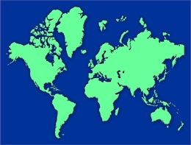
Most websites should not be able to find out where a child / young person is.

It should be easy to get information about children and young people taken off online places like Facebook.
It should be easy for children / young people / whānau to find out what information someone has about them.
Websites should not use information about children and young people to show them adverts.

Here is another box you can tick if you think it could assist with keeping information about children and young people safe.
The terms and conditions for websites / apps should be written in a way children and young people can understand.

Terms and conditions means an agreement between:
a business / organisation
a customer / client.

The terms and conditions say what everyone:
will do
will not do.
Here are more boxes you can tick about things that could assist with keeping information about children and young people safe.

I do not think anything about privacy for children and young people should change.
I have another idea about how to keep information about children and young people safe.

If you have another idea write it on the lines:

Write your ideas on the lines:

Do you have any ideas about how places can do better at showing / telling everyone how they keep information about children and young people safe?

Whānau / families

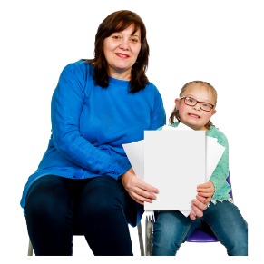
Whānau / families can support children and young people to take care of their information.
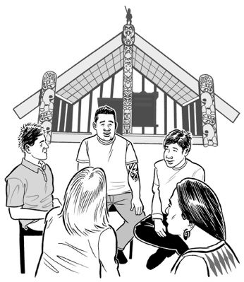

Groups like iwi / hapū can support children and young people too.

Here are some ideas about things that could support families / iwi to support children and young people with privacy.

We want to know if you agree with these ideas.

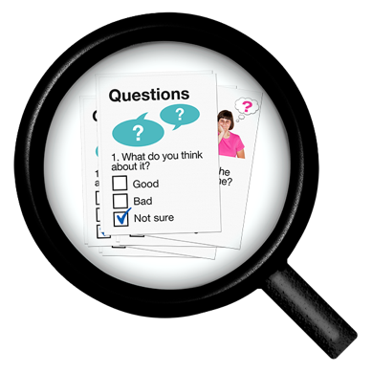
There are questions about whānau / families on pages 40 to 41.

There are questions about iwi / hapū on page 42 to 43.

Put a tick in the box beside your answer:

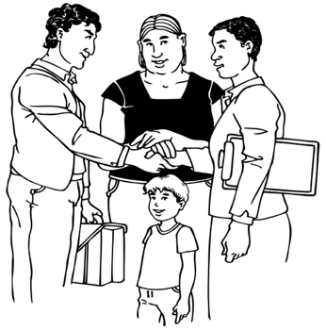
Do you think whānau / families should be able to see information about the children and young people they look after?

yes

no

If you ticked yes write on the lines what information you think whānau / families should be able to see.

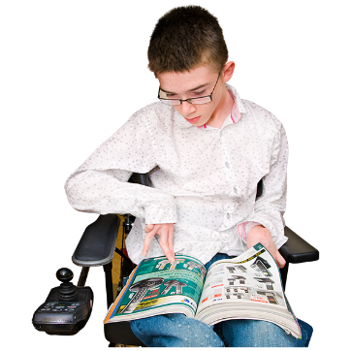
If you ticked no write on the lines why you think whānau / families should not be able to see information about children and young people they look after.

Put a tick in the box beside your answer:

Do you think iwi / hapū should be able to see information about the children and young people they look after?

yes

no

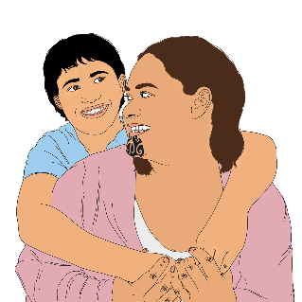
If you ticked yes write on the lines what information you think iwi /hapū should be able to see.
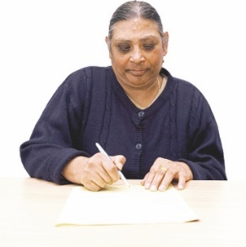

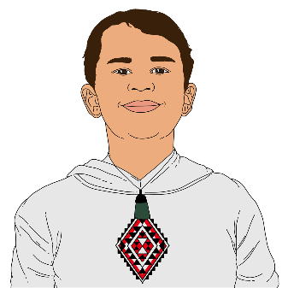
If you ticked no write on the lines why you think iwi / hapū should not be able to see information about children and young people they look after.

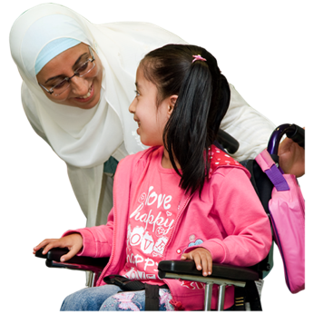
Children need a lot of support with privacy when they are young.

Some children and young people might not want their whānau / family to see all their information.

Write your answer on the line.

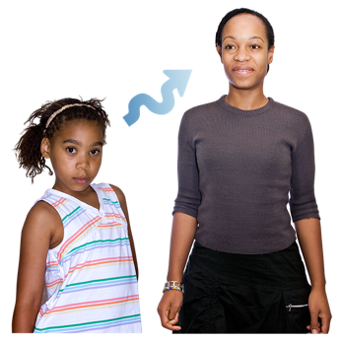
How old should children and young people be to choose who can see their private information?

Put a tick in the box beside your answer.

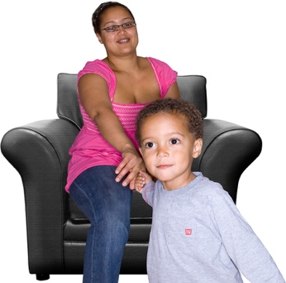
Are there times when information should only be shared with consent from both:
the child / young person
their parent / guardian?
yes

no

If you said yes write on the lines when you think it needs consent from both people to share information.

Write your answer on the line:

What age should children and young people be to use social media like Facebook without their parent / guardian saying it is okay?

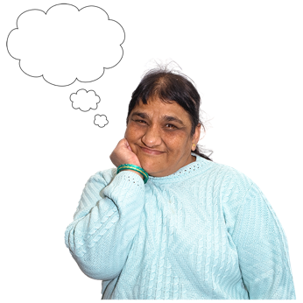
Write anything else you would like us to know about privacy for children and young people on the lines:

Thank you

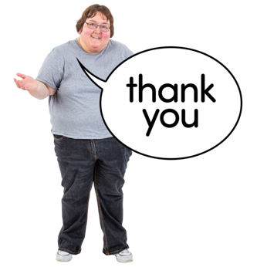
Thank you for taking part in this survey.

This is the end of the survey.

You need to get the survey back to us by:

30 November 2023

The information about where to send your survey is on pages 11 to 13 of this document.

You can find out more about this research in the Easy Read document:

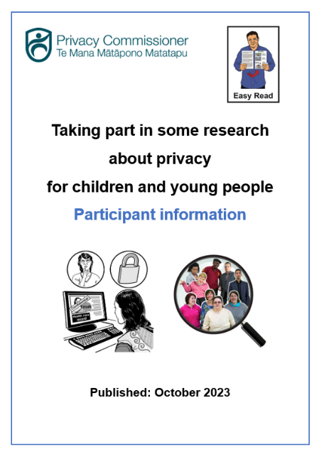
Taking part in some research about privacy for children and young people: Participant information

You can find this Easy Read document on this website:

https://tinyurl.com/mt75x7nw

This information has been written by the Office of the Privacy Commissioner.

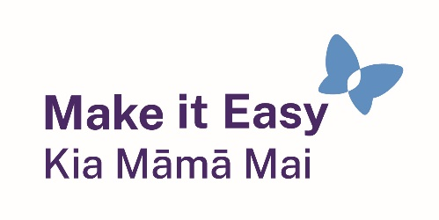
It has been translated into Easy Read with advice from the Make it Easy Kia Māmā Mai service of People First New Zealand Inc. Ngā Tāngata Tuatahi.

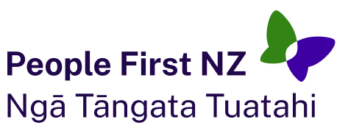
The ideas in this document are not the ideas of People First New Zealand Ngā Tāngata Tuatahi.

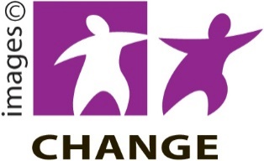
Make it Easy uses images from:

- Changepeople.org

            - Photosymbols.com

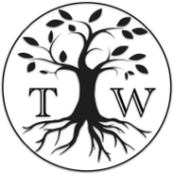
- SGC Image Works
- Huriana Kopeke-Te Aho
- T. Wood.
All images used in this Easy Read document are subject to copyright rules and cannot be used without permission.

