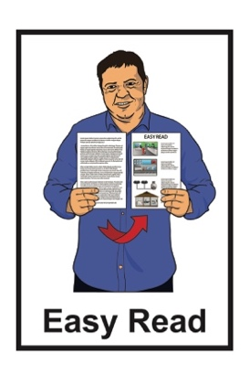

Taking part in some research about privacy
for children and young people

Privacy statement
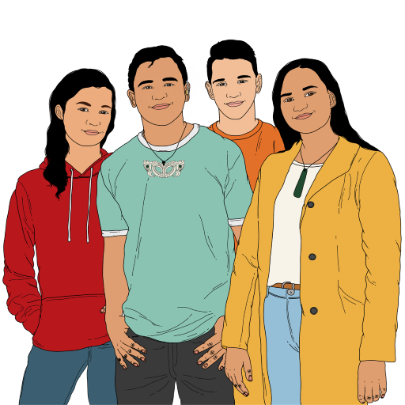
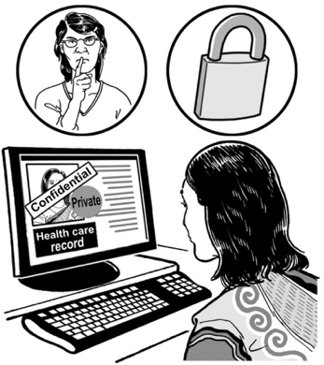

Published: October 2023

What you will find in here

Page number:

What is in this document 2
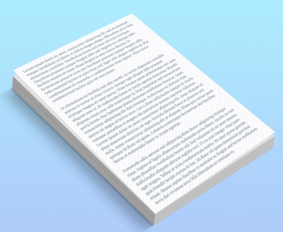

How we will take care of
your information 7

More information 10

What is in this document
This Easy Read document is by the Office of the Privacy Commissioner.

The Office of the Privacy Commissioner is the part of the Government that is in charge of privacy.

The Government cannot tell the Office of the Privacy Commissioner what to do.

Privacy means being in charge of information about yourself.

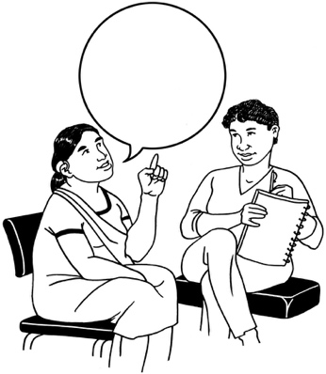
Privacy means you know:
who has information about you
how information about you is used
how information about you is kept safe.

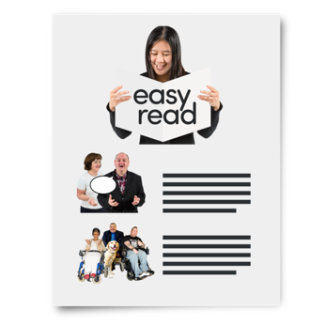
In this document we will call the Office of the Privacy Commissioner the OPC.

When you see the words we / us in this document it means the OPC.

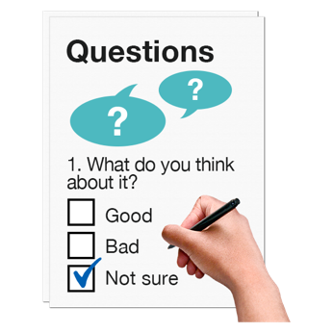
The OPC is doing a survey about privacy for children and young people.

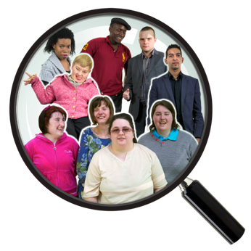
A survey is a way to do research by asking a lot of people to answer questions.

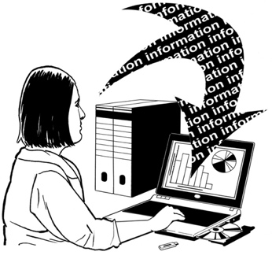
Research is when someone:
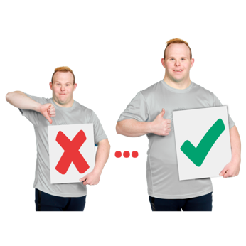
looks at what has happened
tries to find ways to do things differently.

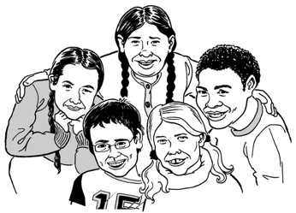
Children and young people means everyone who is younger than 18 years old.

This document is a privacy statement for people who want to answer the survey.

The privacy statement tells you how the OPC will:
use your information
store your information
share your information.

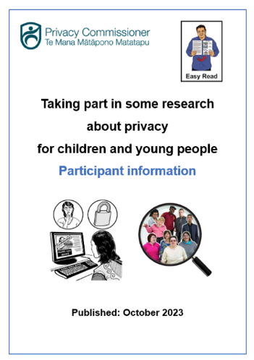
To find out more about the survey you can read the participant information document at:

https://tinyurl.com/mt75x7nw

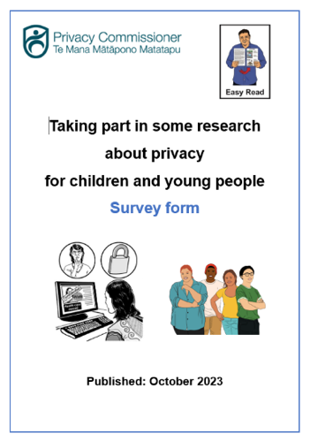
You can find the survey at:

https://tinyurl.com/mt75x7nw

How we will take care of your information

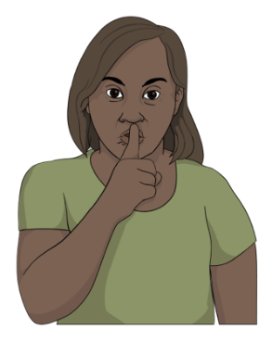
You do not need to tell us:
your name
where you live
anything that could tell people who you are.

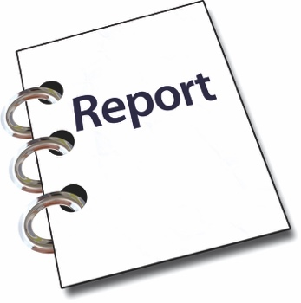
Some of the information you give us might go in our report.

Report means a document that says:
how we did our research
what we found out
what we think should happen.

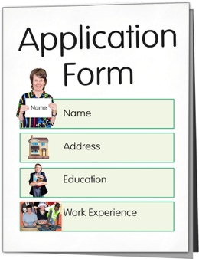
Our report will not use information that would make it easy for people to find out who you are.

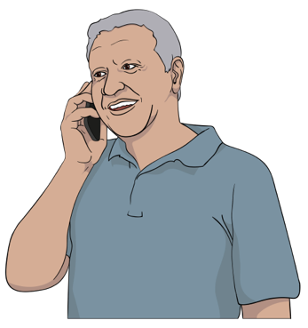
You can ask us to tell you what information we have about you.

You can tell us to fix any wrong information we have about you.

We will only share your information:
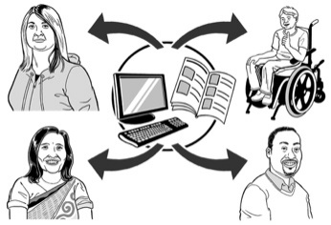
with the people working on the survey
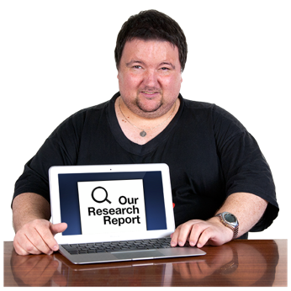
with the people writing the report
if the law says we have to.

We will keep your information in the cloud.

The cloud is a way of storing information on the internet.

The cloud can store a lot more information than a home computer.

It can be a safe way to store information.

We will do everything we can to keep your information safe.

More information

If you have questions about this privacy statement you can call us on the phone at:

0800 803 909

You can phone us:
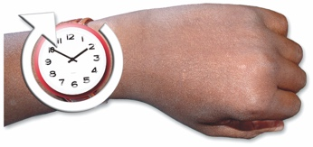
on Monday to Friday
from 10 am to 3 pm.

You can use the New Zealand Relay service when you call us.

If you find it hard to use the phone the New Zealand Relay service is for people who are:

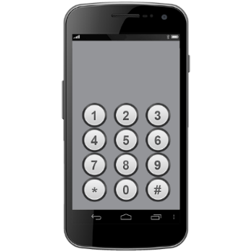
- Deaf / hard of hearing

- deafblind

- speech impaired / find it hard to talk.

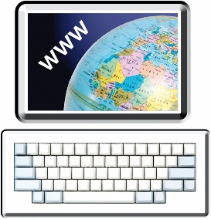
You can find out more about the New Zealand Relay service at:

www.nzrelay.co.nz

This information was written by the Office of the Privacy Commissioner.

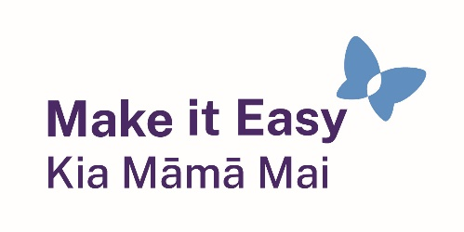
It has been translated into Easy Read with advice from the Make it Easy Kia Māmā Mai service of People First New Zealand Inc. Ngā Tāngata Tuatahi.
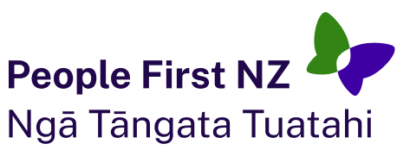
The ideas in this document are not the ideas of People First New Zealand Ngā Tāngata Tuatahi.
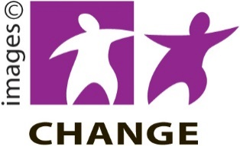
Make it Easy uses images from:

- Changepeople.org

            - Photosymbols.com

- SGC Image Works
- Huriana Kopeke-Te Aho
- T. Wood.
All images used in this Easy Read document are subject to copyright rules and cannot be used without permission.

