SPOT CHECK ON CREDIT REPORTERS

October 2018 – February 2019

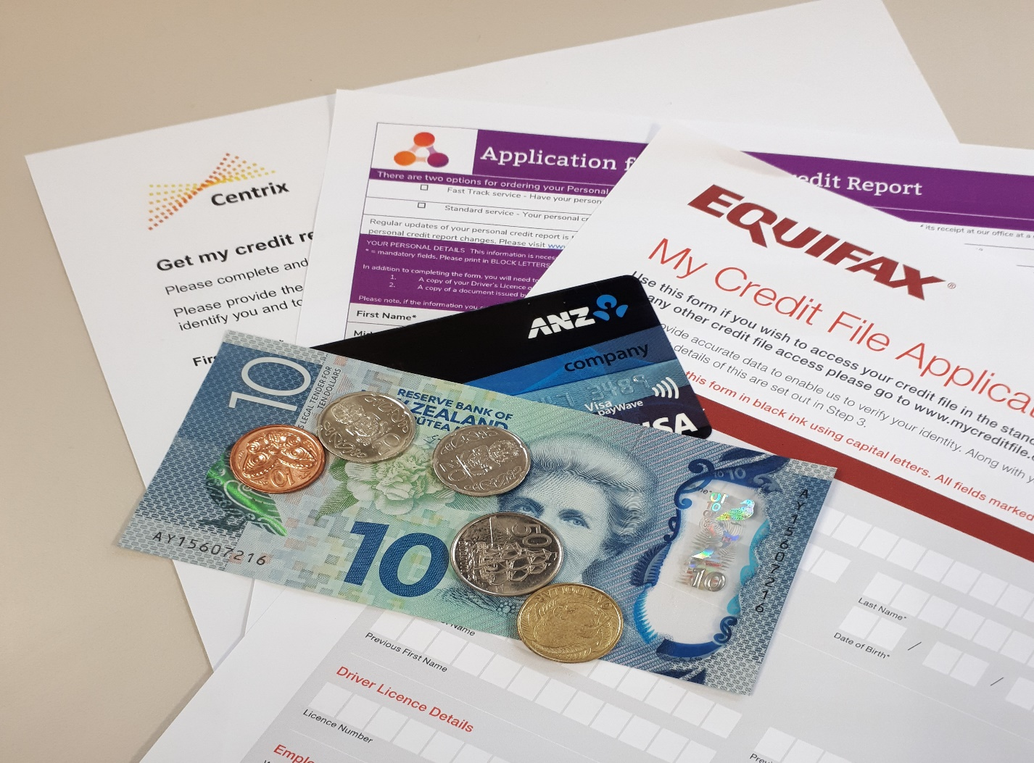

30 April 2019
SPOT CHECK ON CREDIT REPORTER COMPLIANCE

Introduction
Between October 2018 and February 2019, the Office of the Privacy Commissioner (OPC) conducted a spot check on the three national consumer credit reporters – Centrix, Equifax and illion.
The spot checks tested credit reporter practice in providing individuals access to their credit information.
The spot check was conducted using a ‘mystery shopping’ process. To do this, we arranged through a contractor for 30 people to seek their own credit reports and report on their experience.
Headline results:

- Credit reporters are often failing to meet the 5 working day timeliness rule for expedited reports.

- Credit reporters are generally meeting timeliness for free reports but should be striving to provide reports as quickly as practicable.

- Equifax and illion websites are difficult to navigate and need to more clearly advise consumers they can request a free credit report.

- Equifax’s credit reports should explain in more detail how its credit score is derived and what can affect the score.

Background and context
The Credit Reporting Privacy Code 2004 (the Code) gives people the right to access the reports that credit reporters hold about them quickly, and to access it for free.
As the information on credit reports is constantly changing, it is important for consumers to have timely and regular access to credit information to check that it is accurate. It can be particularly useful for consumers to check their credit information before seeking credit to ensure it is accurate and to ask for the credit reporter to correct any errors.
Identity fraud is an increasing problem for consumers. Checking credit reports can help identify identity theft, such as credit accounts never applied for, unknown credit defaults or unauthorised credit enquiries. In those instances, consumers can ask the credit reporter to suppress ('freeze') their credit information.
The Code allows credit reporters to charge up to $10 for an expedited report within 5 working days but it also requires credit reporters to provide credit reports for free as quickly as practicable.
The spot check tested whether credit reporters complied with access rules and limits on charging as at 30 March 2019. From 1 July 2019, credit reporters must provide free credit reports within 10 working days (currently 20 working days), and expedited reports within 3 working days (currently 5 working days).

Methodology
We collected data contained in this report through a contractor who recruited 30 participants to request their own credit reports from each of the three national consumer credit reporters – Centrix, Equifax and illion.
Each participant provided an anonymised copy of their report and completed a feedback questionnaire. The questionnaire recorded the date that reports were requested and received, and whether it was clear that access to a free standard report was available. We also sought comments from the participant about the process to access their credit information.
Each participant was instructed to request their credit information using the credit reporter’s website. The only exception was for Centrix where applicants seeking an expedited report were required to make phone contact with the company in addition to filling in an online form.

Findings - Timeliness
Standard service (free service)

Credit reporter | Requests made | Timeliness met  (20 working days) | Average response (days)  2015 results in brackets
Centrix | 20 | 100% | 15.9 (5.1)
Equifax | 9 | 89% | 13.3 (17.1)
illion | 20 | 95% | 6.8 (8.2)

The Code requires credit reporters to give consumers their credit reports as quickly as practicable, and within 20 working days. The 20 working days is a maximum, not a minimum. If credit reporters can deliver credit information in fewer than 20 working days, they are required to do so.
It is important that the public has timely access to their credit information to maintain an awareness of their credit status, to ensure that the information is accurate and to help guard against the risk of identity theft.
While credit reporters are generally providing reports within 20 working days, there were significant differences between each credit reporter’s average amount of time taken to provide people with their credit reports. The results show a marked degradation in service provided by Centrix from being the timeliest provider of information in our 2015 Report to the slowest. The other two providers’ results show a slight improvement in average response times.
From 1 July 2019, Rule 6 of the Code is changing - credit reports requested using the free standard service must be provided within 10 working days (currently 20 working days). Currently only illion is meeting this requirement.
This reduction in the outer time limit reflects the reality that the information is held electronically and is readily packaged. It delivers on a key objective of the Code to enable the unimpeded and prompt access to credit information as a critical measure to promote trust and accuracy. The changes also help to ensure that consumers at risk of identity fraud can exercise their rights to get an initial credit suppression more quickly, making it more difficult for a fraudster to obtain credit in someone else’s name.
Fast track / Alert Service (paid service)

Credit reporter | Requests made | Timeliness met  (5 working days) | Average response (days)
Centrix | 10 | 70% | 5.9
Equifax | 10 | 90% | 5.6
Equifax Alert Service | 10 | 100% | 1.0
illion | 9 | 56% | 4.7

Credit reporters may make a reasonable charge (up to $10) to cover the cost of providing expedited reports to consumers needing access to their credit information within 5 working days, for example where access is required faster than the 20 working days prescribed for free access.

Credit reporters are often failing to meet the 5 working day timeliness requirement for expedited reports. illion proved to be the poorest performer with only 5 of the 9 reports being provided within time.

The Equifax My Credit Alert monthly report and credit score is a new service (different to the expedited service) provided for a $7.95 monthly fee. Credit reports requested through this service were all provided within one day indicating that Equifax has the capability to provide reports quickly.

From 1 July 2019, the Code will require credit reporters to provide an expedited credit report within 3 working days (currently 5 working days) to support faster consumer access when that is required. The tightened timeframe is in proportion with the reduction in the outer time limit from 20 to 10 working days for the standard service.
Free services and charging
We asked each participant requesting a credit report through the credit reporter website if it was clear they could access a free standard report or credit score.
Feedback from participants suggests Equifax and illion need to do more to make it clear that a free credit report service is available.

Credit reporter | Access to free report clear
Centrix | 93%
Equifax | 77%
illion | 83%

Credit reporters can charge up to $10 to provide expedited reports within 5 working days. All three national consumer credit reporters complied with this part of the Code. Expedited reports from illion cost $10, Centrix charges $5 and Equifax charges $9.95.
Maximum reporting periods
We found no instances of non-compliance with the Code requirements.
The Code places time limits for keeping and reporting credit information. Credit reporters can:
- generally disclose credit information for 4 to 5 years and keep it for one further year;
- report on a single bankruptcy or single entry to no asset procedure for 4 years from the date of discharge from bankruptcy or date of discharge from the no asset procedure;
- disclose information about your current accounts until two years after those accounts have closed;
- keep identification information indefinitely; and
- keep information about multiple bankruptcies indefinitely.
The maximum reporting period requirements recognise that the usefulness of credit information diminishes over time. Once information ceases to be an indicator of current behaviour and holds no relevance, retention of that information conflicts with Rule 9 of the Code.
Credit score methodology
To assist a consumer in their understanding of their credit score, the Code requires that a credit reporter explain in general terms how the score is derived and the range within which their score is placed.
Centrix and Equifax include a credit score within their credit reports while illion does not provide one (illion provides a credit score through its Credit Simple subscriber service that is not currently subject to the Code).
Centrix provides a useful fact sheet that accompanies its credit report. The fact sheet explains the factors that contribute to a credit score, where the score sits in relation to other individuals, and what the score means in terms of likely eligibility to credit and other services.
To meet the Code’s requirements Equifax should explain in more detail how its score is derived and what can affect the score to meet the Code’s requirements. Equifax provides the credit score and where the score sits in relation to other individuals but explains in only broad terms that the credit score is based on past credit experiences and could change because of new information added or old information removed from an individual’s credit file.
Credit score results emphasise the importance of transparency
All credit reporters have different subscribers from which they source credit information, so the information held by each credit reporter is not all the same. It is important for consumers to be aware of the credit information held by each credit reporter as this may assist them to understand why they were approved or not approved credit from credit providers.
We compared credit score information for each mystery shopper and found general consistency of scores across the three credit reporters, but with a few outlier results. These outlier results underline the desirability for transparency about how credit scores are derived. Consumers can be subject to tangible differences in service offerings based on credit scores and the increasing use of risk-based pricing models in credit offerings.
To be a responsible lender, credit providers should follow the responsible lending code issued under the Credit Contracts and Consumer Finance Act 2003. The lending code sets out processes, practices or procedures that a lender should follow to comply with the lender responsibility principles.
Clearer access right to credit score from 1 July 2019
Amendment No 14 to the Credit Reporting Privacy Code 2004 includes changes to enable consumers clear access rights to credit score information.
From 1 July 2019, the Code will be amended to provide that if a credit reporter is creating and selling to third parties a credit score or rating that characterises the creditworthiness of a consumer, that consumer is entitled to see that rating.
Credit scores are a core feature of a comprehensive credit reporting system, but these scores are sometimes being treated as a chargeable ‘add on’ when consumers seek access.This undermines consumer’s rights to access their credit information for free. Having access and an understanding of credit score information is important for consumers subject to today’s risk-based pricing models. In contrast, the previous (negative reporting) model was used to identify and exclude poor credit risks but otherwise all approved borrowers tended to be treated alike.
Written transcripts
We found no instances of non-compliance with the Code requirements.
The Privacy Act requires agencies to provide a written transcript for codified repayment information. This written transcript puts repayment information in context to enable consumers to better understand the nature of the information.
In our 2015 spot check on credit reporter compliance we identified that Centrix did not provide a transcript and on those occasions did not meet the requirement of the Privacy Act. All three national consumer credit reporters now appear to comply with this requirement.

Participant comments
We asked participant to comment on the process of accessing their credit reports or credit score. These are a selection of the comments received:
“illion is super confusing and hard to navigate.”
“Equifax site was very difficult to navigate.”
“illion - horrible website and clumsy. Equifax - clumsy password protection.”
“Best service was Centrix - great communication, easy website and application process, fast response.”

Conclusions
This spot check found issues that credit reporters should investigate and address:
- Credit reporters need to address their failure to meet the 5 working day timeliness requirement for expedited reports.

- While credit reporters are generally providing free reports within 20 working days, Credit reporters should be striving to provide reports as quickly as practicable since information is easily retrievable.

- Equifax and illion websites are difficult to navigate and should make it clearer to consumers that they can request a free credit report.

- Equifax’s credit reports should explain in more detail how its credit score is derived and what can affect the score.

APPENDIX – Raw data

Free service – response (days)
Equifax * | illion | Centrix
15 | 3 | 17
11 | 2 | 19
3 | 2 | 16
12 | 4 | 16
Did not proceed | 7 | 17
16 | 17 | 17
21 | 4 | 3
14 | 15 | 17
12 | 7 | 16
16 | 5 | 19
15 | 6 | 17
 | 18 | 16
 | 3 | 15
 | 6 | 16
 | 3 | 17
 | Not received | 17
 | 19 | 19
 | 6 | 17
 | 1 | 17
 | 1 | 10
120 (total) | 129 (total) | 318 (total)
13.3 (average) | 6.8 (average) | 15.9 (average)
* Only 10 free service requests were made as these participants also requested reports through the Equifax Alert Service
Fast Track service – response (days)
Equifax | illion | Centrix
3 | Did not proceed | 20
2 | 3 | 1
5 | 1 | 2
5 | 8 | 16
24 | 1 | 2
4 | 8 | 3
3 | 2 | 5
3 | 8 | 1
2 | 3 | 1
5 | 8 | 8
56 (total) | 42 (total) | 59 (total)
5.6 (average) | 4.7 (average) | 5.9 (average)

Office of the Privacy Commissioner | www.privacy.org.nz | Enquiries 0800 803 909

One Equifax report was not requested due to identity verification issues. The sample size for Equifax was reduced to 10 free reports so that some resource could be allocated to apply for Equifax’s Credit Alert service and maintain an even overall sample selection across the three providers.
One Illion report was never received.
One participant was unable to access the illion service – an undefined technical issue
Rule 9: A credit reporter that holds credit information must not keep that information for longer than is required for the purposes for which the information may lawfully be used.

